**ShadowStalk Inventory Module**

Architecture/Design Document

**Table of Contents**

1 Introduction 3

2 Design Goals 3

3 System Behavior 4

4 Logical View 4

4.1 High-Level Design (Architecture) 5

4.2 Mid-Level Design 6

4.3 Detailed Class Design 7

5 Process View 7

8 Use Case View 8

Change History

**Version:** 0.1

**Modifier:** Jeffrey Armstrong

**Date:** 04/17/2021

**Description of Change:** Creation of base Inventory Component for game pickups.

Changes:

* Changed the class names to fit with current build.
* Updated diagrams for current build.
* Added new classes from current build to Mid-Level Design.
* Updated descriptions to sound more finalized in Logical View.
* Added STK_ItemBase to Case View.

# Introduction

This document describes the architecture and design for the ShadowStalk application being developed for Particle Interactive. ShadowStalk is a heavily stylized asymmetrical co-op horror game where the players must work together to gather keys with the goal of helping lost souls escape the confines of Limbo.

The purpose of this document is to describe the architecture and design of the Interface Module application in a way that addresses the interests and concerns of all major stakeholders.

For this application the major stakeholders are:

* **Developers** – They want an architecture that will minimize complexity and development effort.
* **Project Manager** – The project manager is responsible for assigning tasks and coordinating development work. He or she wants an architecture that divides the system into components of roughly equal size and complexity that can be developed simultaneously with minimal dependencies. For this to happen, the modules need well-defined interfaces. Also, because most individuals specialize in a particular skill or technology, modules should be designed around specific expertise. For example, all UI logic might be encapsulated in one module. Another might have all game logic.
* **Maintenance Programmers** – They want assurance that the system will be easy to evolve and maintain on into the future.

# Design Goals

The design priorities for the Inventory Component system are:

* The design should be open to future development and iterations if needed by the developers.
* The design should have as little complexity as possible in order for it to be more accessible and organized.
* The design should be optimized and openly compatible so items that are added to it at any point during development have as little conflicts in the process as possible.

# System Behavior

The Inventory Component’s purpose is to store and manage collected items with the player being able to toggle between each collected item in the order of when each item was collected.

# Logical View

The Inventory Component works with the Shade Player Module so when the Entity Shade picks up an item, it will be sent to and managed in the Inventory Component.

The STK_PickupBase works closely with the Inventory Component because it manages what a pickup is and the different types of pickups there are while the Inventory Component manages how much of each pickup the Player has. The STK_ItemBase tells the Pickup Base what each item type is and then that information is also told to the Inventory Component through the Pickup Base.

The Inventory Component also works with the STK_EntityCharacterShadeController class so the Shade can toggle and use the different items that are contained and managed in the Inventory Component however this feature does not fully function as of this build.

## High-Level Design (Architecture of the Entire system)

The high-level view or architecture consists of **5** major components:

* The **Entity Module** is a wrapper around Unreal Engine’s standard Pawn class. It holds the game’s custom movement component.
* The **Shade Player Module** is the main driver of the Shade players’ character. It reacts to user input, interacts with the Inventory Module, and controls the Shade’s eyes.
* The **Inventory Module** contains information related to what a Shade player is currently carrying (keys, items, etc.)
* The **Match GameMode Module** is responsible for managing the game state, item spawners, pickups, and doors.
* The **User Interface Module** is responsible for the creation of a series of interfaces and screens that allow players to interact with the game world.

## Mid-Level Design of Inventory Module

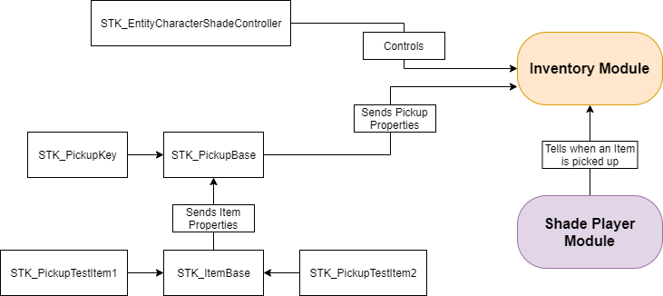

**STK_PickupBase:** The base class for all pickups in the game. It handles the Collision, Mesh, an enum list for all the different types of Pickups, a Particle System, and variable for animation of the Pickups rotating, and bobbing.

**STK_PickupKey:** Tells the STK_PickupBase of its identity as a Key type pickup in the enum list. It is not considered an item as keys are managed differently from regular items.

**STK_ItemBase:** The base class for all items in the game. It is inherited from STK_PickupBase so all of its logic is carried over to the ItemBase but it also has a variable that recognizes a specific Item type.

**STK_PickupTestItem1:** Tells the STK_ItemBase of its identity as a test item type in the enum list. This item was made for temporary testing purposes and will not be included as a final item.

**STK_PickupTestItem2:** Tells the STK_ItemBase of its identity as a test item type in the enum list. This item was made for temporary testing purposes and will not be included as a final item.

**STK_EntityCharacterShadeController:** The controller of the Shade Player and controls the use of the Inventory Component.

## Detailed Class Design of Inventory Module

Please view **UML/InventoryUML.png** for the high-resolution image.

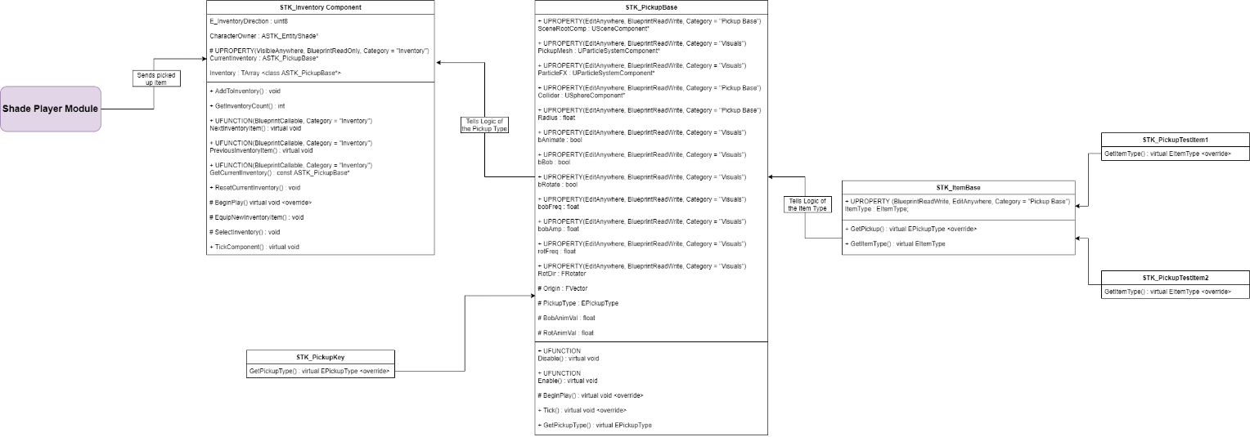

# Process View of Inventory Module

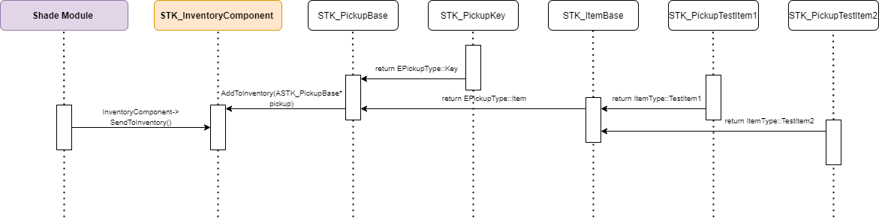

# Use Case View

When the Player picks up an item, STK_CharacterEntityShade class will send it to STK_InventoryComponent to be managed.



STK_InventoryComponent will then add the item to the Inventory to be saved and managed for whenever the player wants to use it.

When the item is being added to the Inventory Component, STK_PickupBase will handle the specific information of said pickup…



and STK_ItemBase will handle the specific information of said item to was picked up.

